**Rest Assured Framework**

* **Setup before working on rest assured framework -**

1. Download the IntelliJ IDE.
   1. Link to download: <https://www.jetbrains.com/idea/download/#section=windows>
2. Create or Import the project.
3. Download the compatible Java JDK which the IDE will ask to download.
4. Set the **environment variables JAVA_HOME and bin path** for the downloaded JDK as below.
   1. System Properties-> Environment Variables.

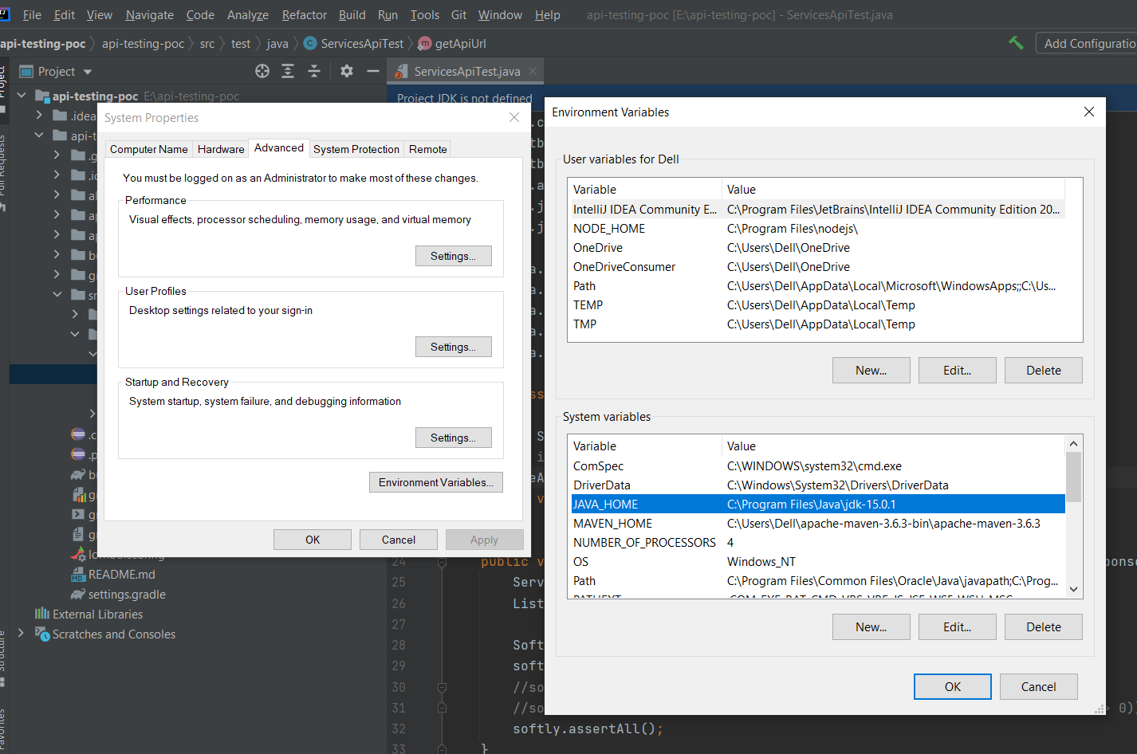

1. Install the Lombok Plugin from the IDE as below
   1. **Lombok**: ***Lombok is a java library tool which is used to minimize or remove the boilerplate code and save the time by using some annotations.***
   2. File-> Settings->Plugins-> Search for Lombok -> Install -> Apply/Ok.
   3. The Plugin gets installed and if required we need to restart the IDE.

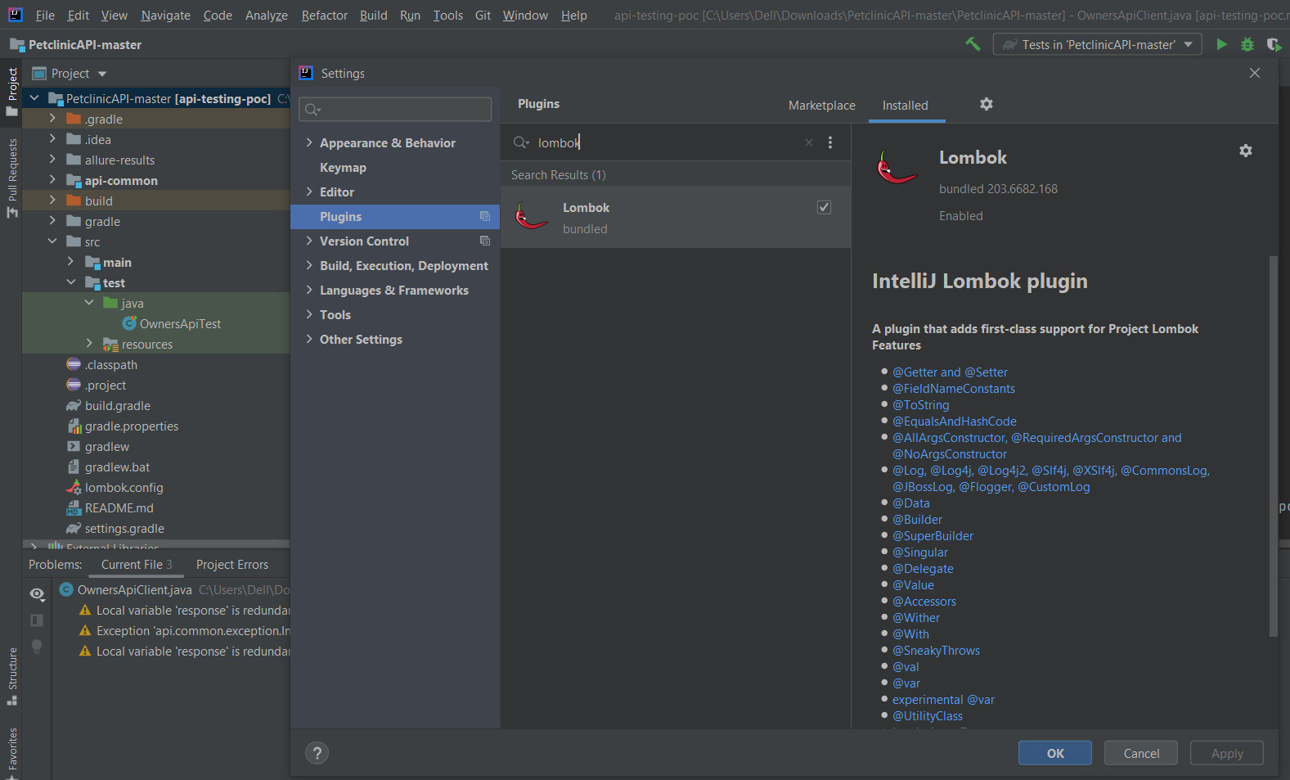

1. Enable the annotations as below.
   1. File-> settings-> Build, execution and deployment -> Compiler->Annotation Processor-> Enable the annotation processing.

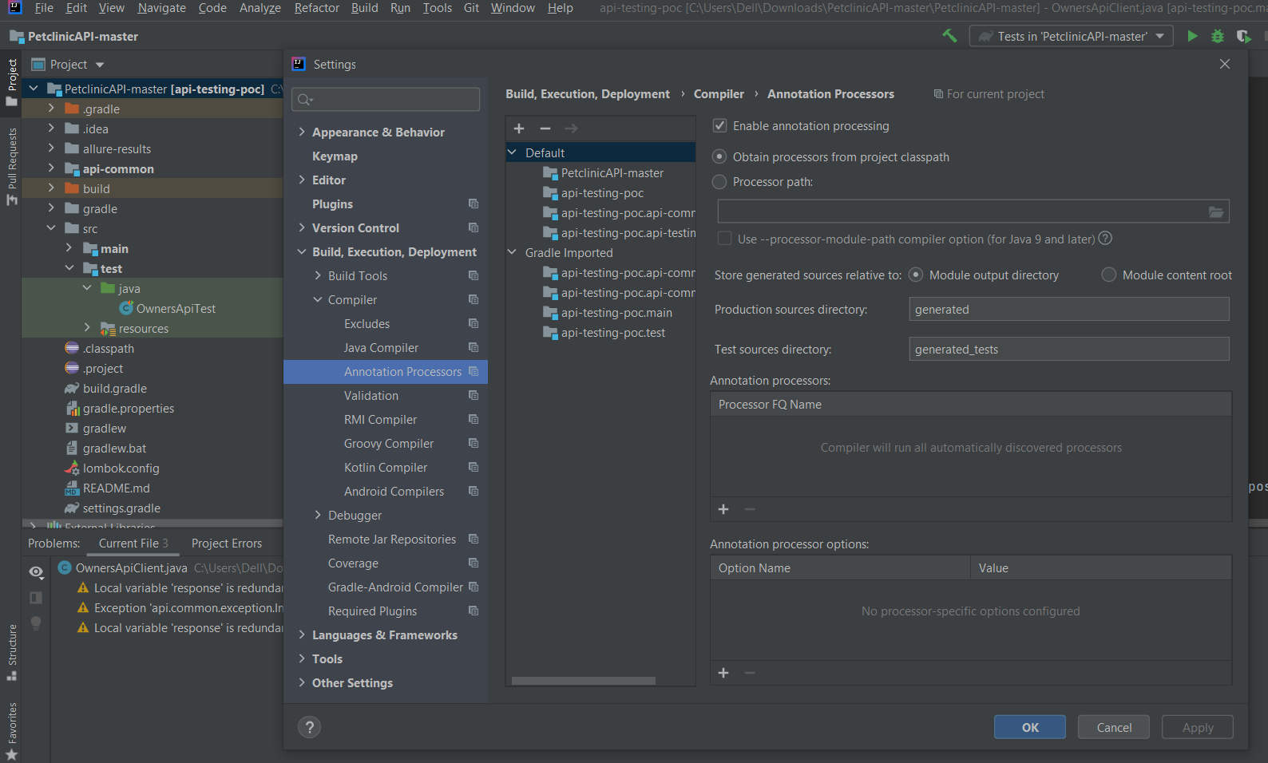

1. Install the plugin for automatically creating the POJO’s for JSON request or response. There are many plugins for this. For e.g. I am downloading for RoboPOJOGenerator.
   1. File-> Settings->Plugins-> Search for RoboPOJOGenerator -> Install -> Apply/Ok.

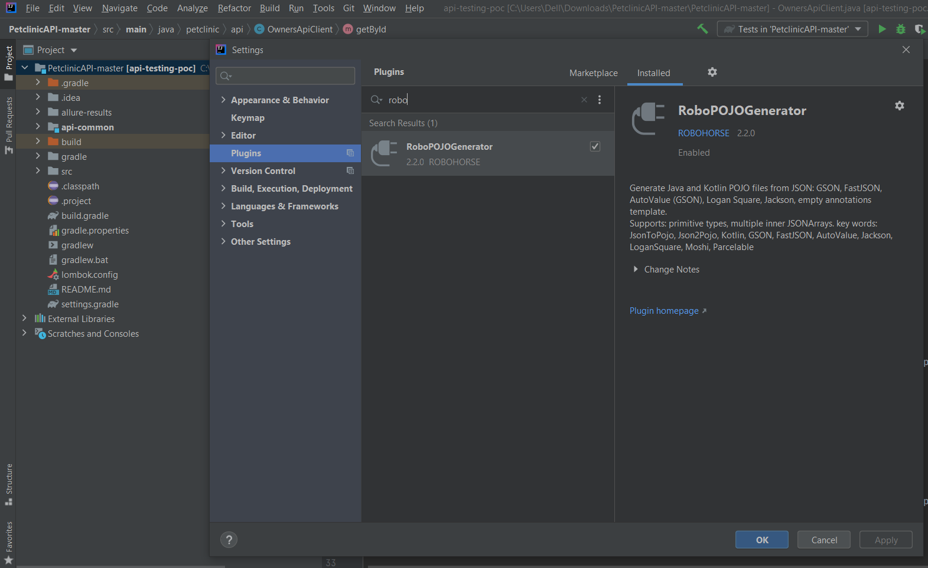

* **Additional Setup with SCM - GIT:** Creating a repository in GitHub through IntelliJ IDE and Pushing the code.

1. We need to share our project to GitHub

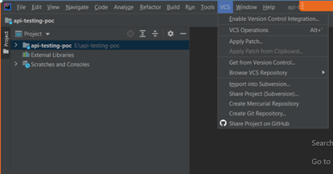

1. After clicking on Share Project on GitHub, it will open a login pop-up for GitHub.

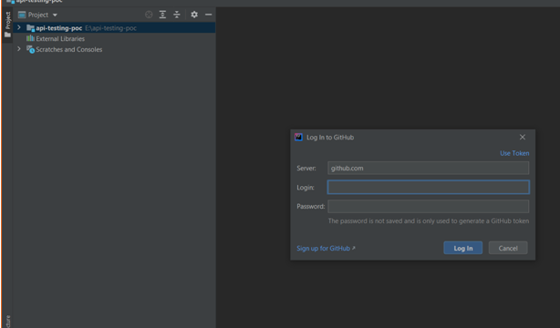

1. Provide the valid credentials and click the log in button. If successful login, then we will navigate to the GitHub browser.

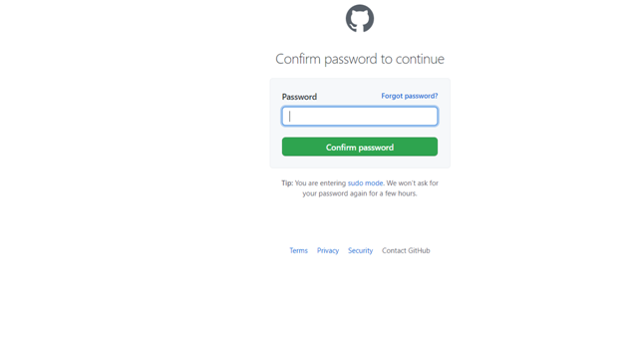

1. If the login is not successful, then we can follow below steps.
2. Click on the Use Token link as per below image.

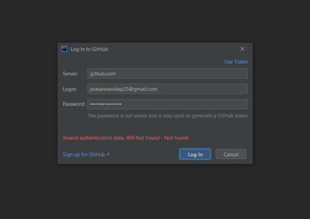

1. After clicking on Use Token link, we will get below pop-up . Now we need to generate the Token.
2. So click on Generate.

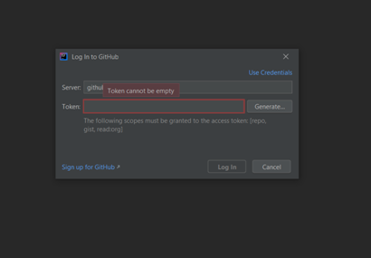

1. Again, it will ask for confirm password as point 2. So enter the password and we will navigate to below page.

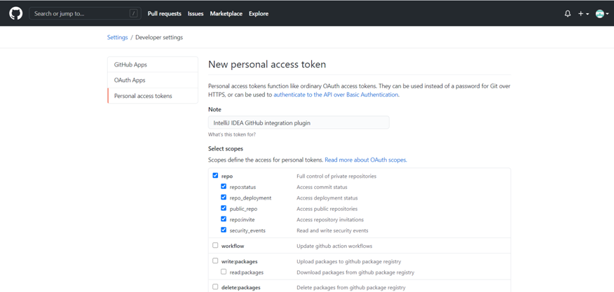

1. On the below page we will find the Generate Token button. We need to click on it to generate the Token.

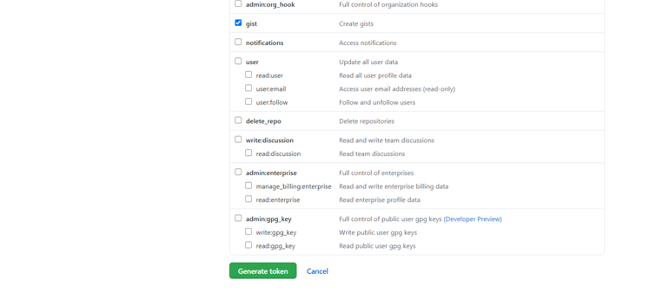

1. After clicking on generate token we will get our token in below way.

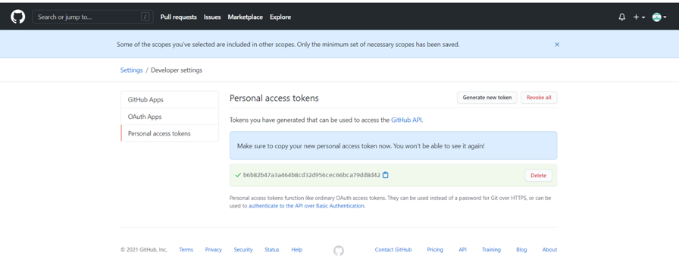

1. Use this token and paste in the pop-up. And click on Login.

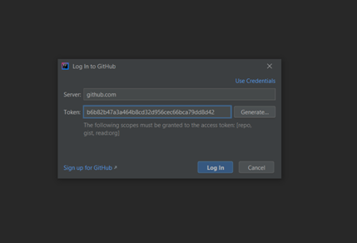

1. One more pop-up is opened asking for repository name, remote name and description. Provide the details and click on share button.

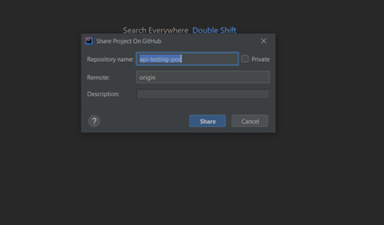

1. Now we need to add our files to git repository. By default all our files are selected. Enter the commit message and click on add button.

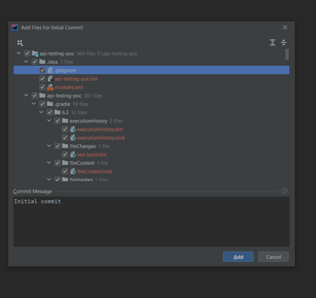

1. Now we have added our project to GitHub repository successfully and we will get message as below.

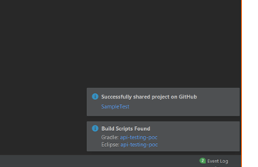

1. Now we need to commit our code and push the code. For this Go to Git->Commit

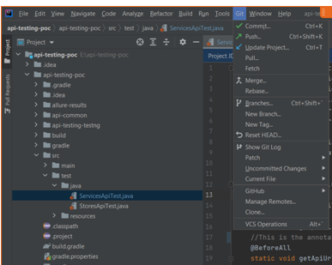

1. Below pop up is opened which shows what changes we have made and in which files

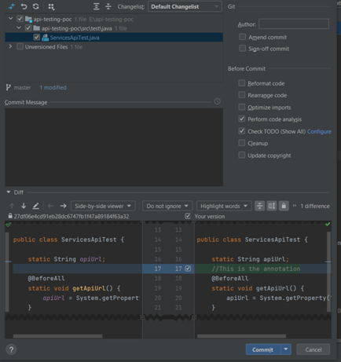

1. Click commit and push from the dropdown and Enter the commit message.

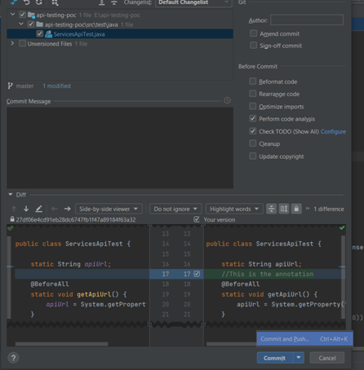

1. Push window is opened. We need to click on the Push button

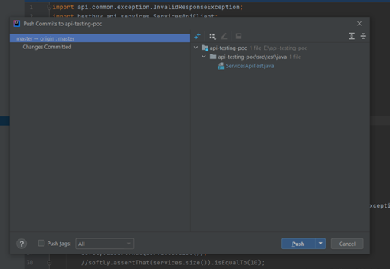

1. We have pushed the code to repo now.

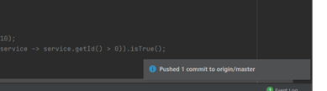

1. This is the process for creating the repo, committing the code and pushing our code to repo.